The artificial intelligence
- What is the artificial intelligence? (5 points)
- systems that are able to complete a variety of tasks
- systems that are able to perform tasks requiring human intelligence
- systems that are able to perform tasks after getting information about the world
- systems that are able to perform in different conditions

- What are main parts of the artificial intelligence? (5 points)
- Machine learning
- Computer vision
- Applications development
- Natural language processing

- What is a specific feature of a rational agent? (5 points)
- A sequence of actions that can be executed
- A sequence of actions that leads to the final goal
- A sequence of actions that minimizes the time required to complete the task
- A sequence of actions that maximizes the performance measure

- What is not a feature of a rational agent? (5 points)
- Sensors
- Actuators
- Restoration
- Performance measure

- What a search strategy are we going to use if the search space is represented by search trees, and a wanted object is located in upper levels? (5 points)
- Heuristic search
- Backtracking search
- Breadth-first search
- Depth-first search

- What a search strategy are we going to use if the search space is represented by search trees, and a wanted object is located in lower levels? (5 points)
- Backgammon
- Heuristic search
- Depth-first search
- Uniform cost search

- What a search strategy are we going to use if the search space is represented by a graph of roads with the distance between nodes? (5 points)
- Uniform cost search
- Breadth-first search
- Backtracking search
- Depth-first search

- What will be a value of the root node if we have the following minimax problem (5 points)
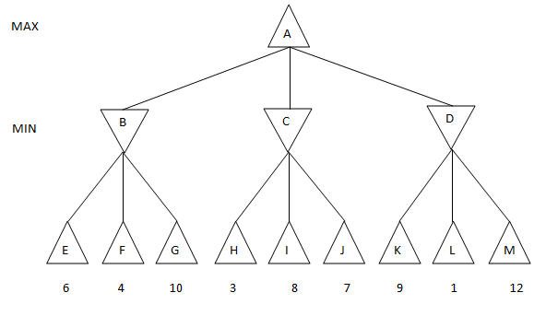
- 7
- 1
- 4
- 6
The practical part
- Build a rational agent that will have a definite goal, and describe ways how its performance could be optimized. You need to include all parameters: performance, environment, actuators, sensors. (25 points)
- In this task you need to build the behavior of the agent in his search of gold taking in account a condition that he does not have any information about Wumpus cave’s internal structure. (25 points)
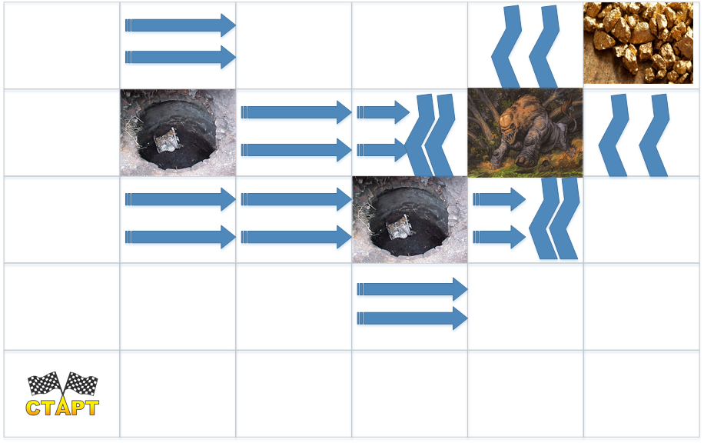
- Use the breadth-first and the depth-first search to find a node (10) in this tree (10 points)
